ISSN 2395-1621 | Effective Data Migration and Implementation of BOM Management Using PLM System  ^{#1}Prasad S. Patil, ^{#2}Prof.A.U.Gandigude  ¹prasadpatil.1809@gmail.com  ²ashish.gandigude@zealeducation.com  ^{#1 2} Department Mechanical Engineering, Dnyanganga College of Engineering & Research, Pune-41, Maharashtra, India


ABSTRACT | ARTICLE INFO
Product Lifecycle Management (PLM) is the business activity of managing a company's products all the way across the lifecycle in the most effective way. The CAD data gives all design information produced throughout the lifetime of a product is completely and meaningfully transferred to the new system. The multiple BOM representations manages complex products can improve quality of product, time-to-market requirement, reduces product development, manufacturing and product lifecycle costs in order to remain competitive. BOM management in software is a critical task. Effective BOM management provides tailored visibility to central product information, and extends configuration management beyond the BOM to include a richer product definition. A PLM solution Teamcenter enables us to manage complex product definitions that include product options and variability. Users can manage discrete product variants configuration, enabling more options without additional effort. This paper is mainly focused on migration of NX data into Teamcenter by utility and present BOM management by using Teamcenter structure manager and Customization.  Keywords— BOM, NX data Migration, PLM, Teamcenter Customization. | Article History  Received :18th November 2015  Received in revised form :  19th November 2015  Accepted : 21st November , 2015  Published online :  22nd November 2015

- Introduction
PLM is the business strategy for collaborative creation, management and use of the product definition information from product concept to end of product life. This integrates people, processes, business system and information [1]. Organizations are increasingly adopting new-age PLM systems to support their changing organizational needs. So, they need migration of their existing CAD data. PLM data migration provides an intelligent approach for migrating CAD data in PLM applications by assisting the right migration approach. PLM manages product information across the extended enterprise throughout the product lifecycle. The design and management of critical part are done by bill of material [2]. The bill of material (BOM) is a list of the parts or components that make company’s

product a reality. PLM keeps BOM data centralized, controlled, and up-to-date this provide advantage of fewer errors and rework, higher quality and better cost control. Teamcenter BOM management helps to manage part with total visibility into product definition. The Teamcenter Bill of Materials management solution allows you to manage your complete BOM in a single environment definition. Teamcenter manages BOM information relevant to product functional needs. BOM management facilities are use to manage product platform, variants and derivatives, essential for improving product customization and reuse. Teamcenter customization provides effective BOM with the use of advanced APIs to support customer-oriented environment as per organization need [3]. Teamcenter uses the various concepts like Variants, Validation, Global Alternatives, Local Alternative uses for BOM management.

- Concept of PLM
Today, As per market requirement products are more complex with costly technologies, unique needs at the lowest possible cost [4].Product life cycle management is process used for manage data and design process associated with life of the product from its concept through design, manufacturing, sale, service, support, reengineering to end of the life [5].In organization, PLM help to integrate personnel’s, data, date, processes, and business system for managing product related information across enterprise [6]. During phase of product life larger amount of data is generated. This includes CAD files, product specifications, quality documents, Bill of materials, production and manufacturing data [7] After implementing PLM system in organization, this provide benefits to improve business to improve business efficiency by achieving reduction in time and cost for product change, short product lifecycle and lead time, decrease scrap and rework of product, link between production and design engineering [1].
PLM has following fundamental concepts [8]: 1] A universal, secure, managed access and use of product definition information
2] The persistent integrity of product definition and related information throughout the life of product.

- Data Migration
Data held in legacy systems is an important business resource. Data migration is the process of importing legacy data to a new system with entering the data manually, new developed custom software, or other ways. Legacy data is the recorded information that exists in your current storage system, and can include CAD files, Word files, spread sheets, paper documents and images. All these type of data formats need to migrate into new implemented system.
- Bulk vs. Phase wise migration-

These are two ways of migration. The wise Migration is selected for project work.
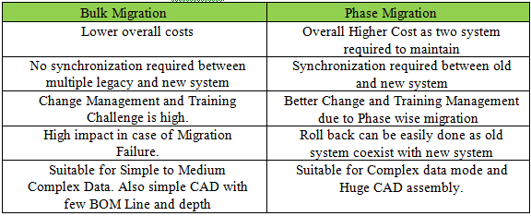Fig.1 Bulk vs. Phase Wise Migration
- NX CAD data Migration-
NX CAD Migration is one of the important aspects of PLM migration process. CAD migration is usually done by third party tool which has CAD integration capability with the given system. For example Siemens PLM provide Autodesk Inventor. Company business requirement is migration their existing NX data into Teamcenter. Company has a huge range of product list of products all these products are to be migrating in Teamcenter. The Siemens PLM provide a tool for UG NX name as ug_import. This tool is available in UGMANAGER folder which is present in NX installed files. For migration we need to set TC_ROOT and TC_DATA path with tc_profilevars.bat. For this method required Synchronization between NX and Teamcenter and need excel macro file provides mapping Text file. For example, NX V6_assembly used for migration into teamcenter.
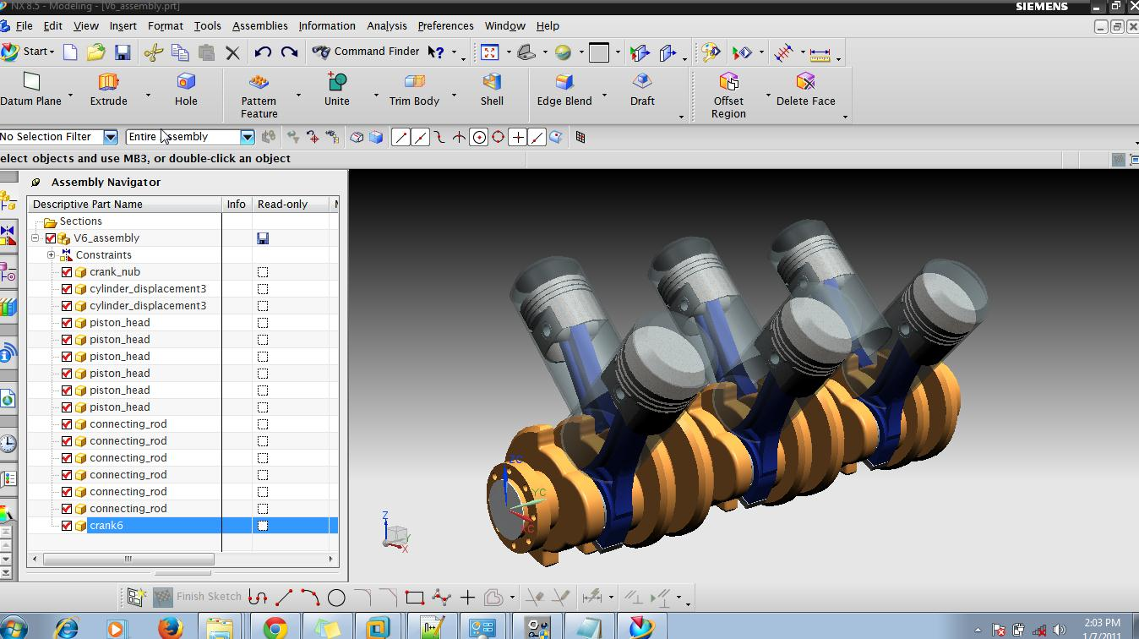 Fig. 2 V6_assembly in NX
After opening assembly in NX fig.2 assembly need to export into spreadsheet and copy the descriptive part name list. Open excel sheet has custom macro having data of Part name, Item_id and rev_id. Give descriptive part name list to Part name. Provide Item_id’s and rev_id’s as an “ITEM-20001” and “A” resp. After filling all in excel sheet, run macro which develop mapping text file in system disk. The new created mapping file is shown in fig.3 of V6_assembly.
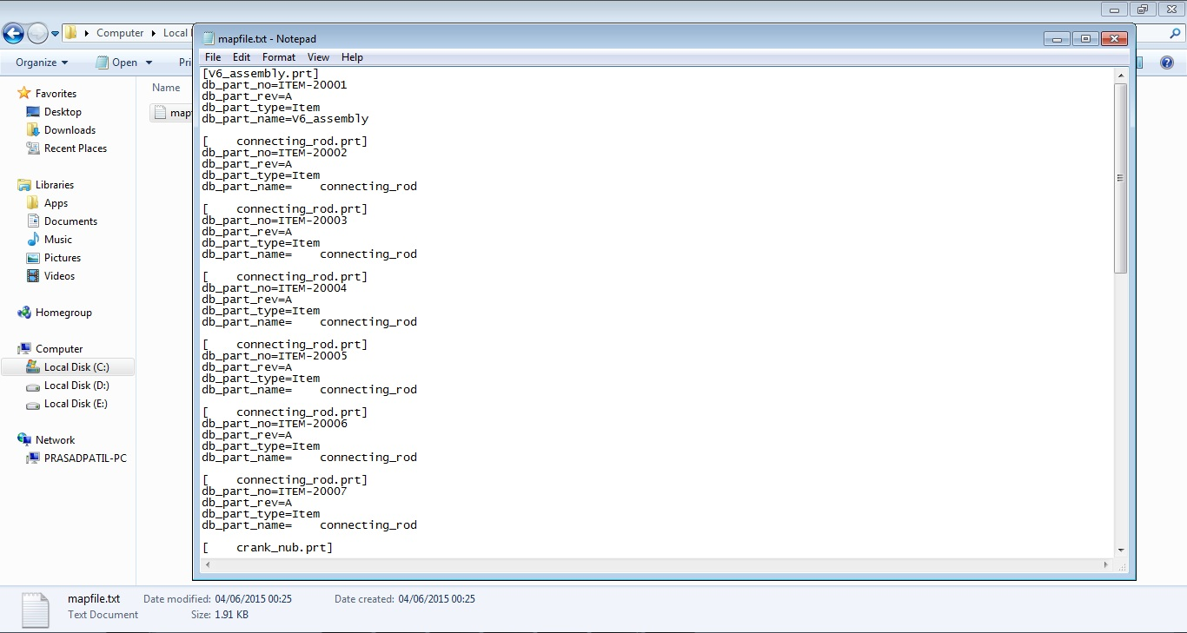Fig. 3 Mapfile in Text Format
The next step is run the ug_import tool in command prompt of Teamcenter. In command prompt we need to provide some supporting arguments. Such as,-u is for specifies the user ID, -p is for specifies user password, -g is for specifies user group, -mapping is for specifies mapping file path, -part is for specifies assembly part path and –import_folder is for specifies name of folder create in teamcenter contains migrated parts. In fig.4 ug_import is used for V6_assembly.
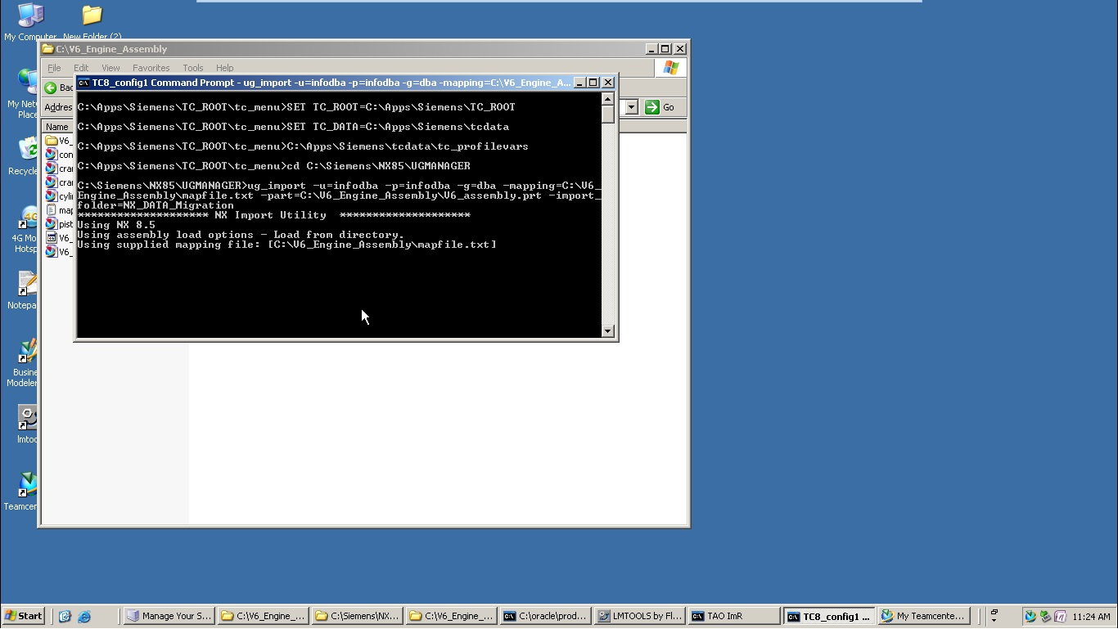Fig. 4 Ug_import Utility Tool Run
The time required for migration is depending on computer configuration. When migration is successful, open the teamcenter for that particular user session used in utility. The NX Data is found in Folder present in Teamcenter name used in utility. In fig.5 Migrated NX assembly is shown in teamcenter structure manager.
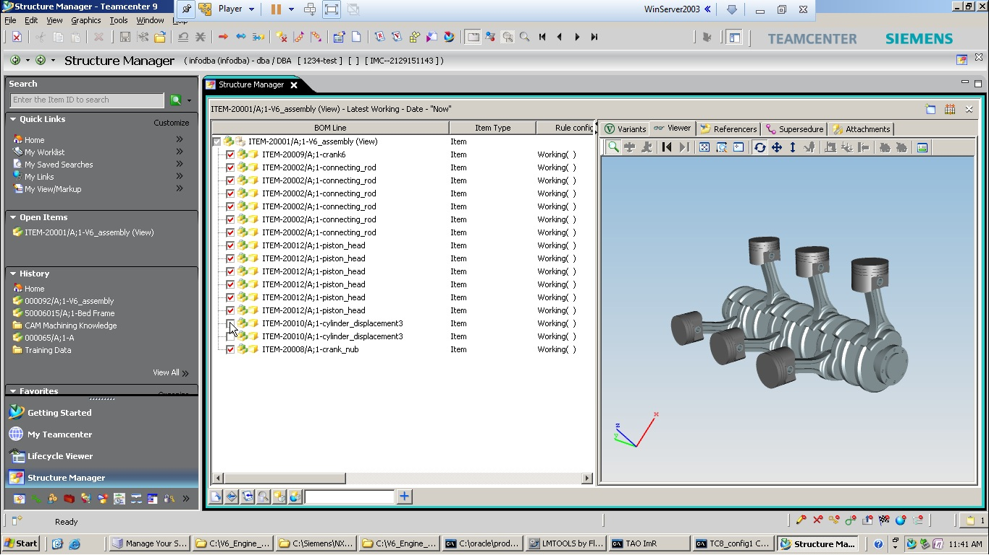Fig. 5 NX CAD Data in Teamcenter Structure Manager
- Bom in Teamcenter
BOM management is most critical task in PLM system because of complexity of product data, multiple requirements of product data and multiple representation requirement of enterprise. The definition of BOM is “A compressive list of raw material, components and assemblies required to build or manufacture a product”. The some types of BOM are such as Design BOM (EBOM), Material BOM, Manufacturing BOM (MBOM), Service BOM and Master BOM [9]. Mater BOM shows in fig.6
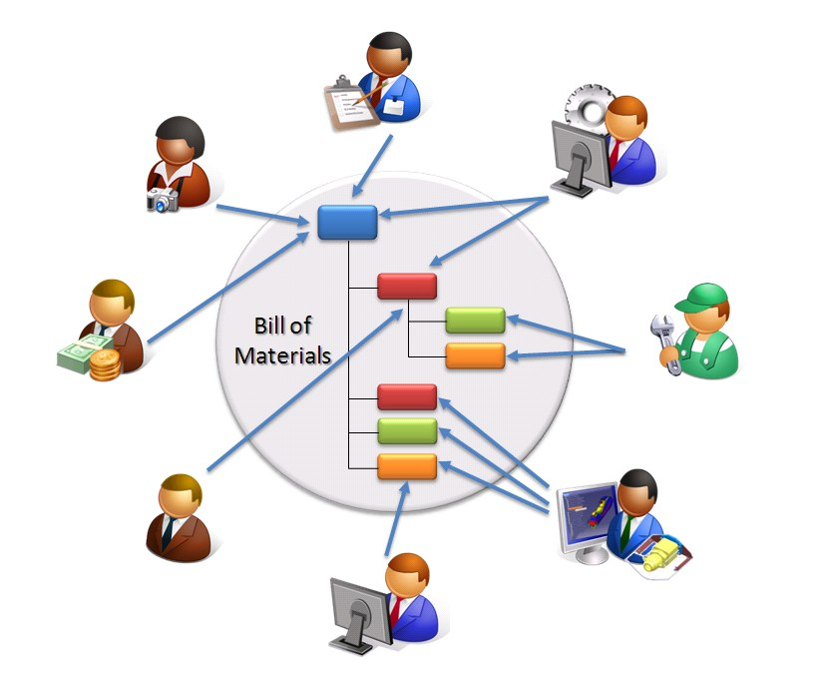 Fig. 6 Master BOM
Bill of materials (BOM) management in Teamcenter help you manage increasingly complex products by providing total visibility into your product definitions and configurations and describe the way this information evolves throughout the product lifecycle. Teamcenter BOM manages information relevant to product functional needs. Teamcenter BOM management manages product variants, platforms and derivatives essential for improving product changes and its re-use [10]. The Teamcenter BOM management solution facilitates to manage complete BOM in a single environment from simple structures to complex product structure. A single source of BOM information ensures accuracy and completeness for all stakeholders. This eliminate the need to maintain, combine and verify all the various pieces of BOM information historically stored in separate systems, databases, and spreadsheets [11].
Tools used for BOM management in Teamcenter [12], [13]-
- Packing and unpacking product structure-1
Grouping multiple identical components in one level of an assembly is known as packing. You can pack components if they satisfy all of the requirements such as they have the same item revision and they have the same find number. If a designer is working on a V6 Engine design, it is time-consuming to negotiate 6 individual connecting rods within the V6 assembly, if each connecting rod is identical except for its position. A result is come in BOM Line as connecting rod x 6 entry. Vice-versa of this un-grouping of component in one level is known as unpacking. We apply this option from view ribbon. Fig.7 shows pack and unpack structure.
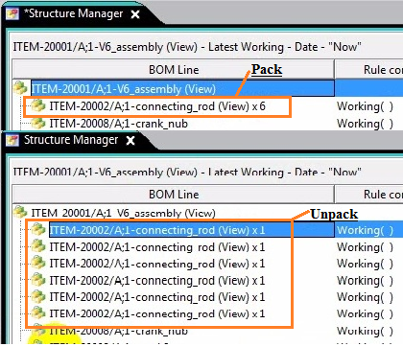
Fig. 7 Pack and Unpack
- Precise & Imprecise
In assembly we use precise for to set fixed/static structure and imprecise for changeable structure. Precise and imprecise are handles by revision rules. If an assembly is precise and the revision rule contains a precise entry, the assembly is configured according to that entry. However, if the assembly is precise and the revision rule does not contain a precise entry, the assembly is treated as imprecise. In fig.8 Item-20002/C-1 is precise.
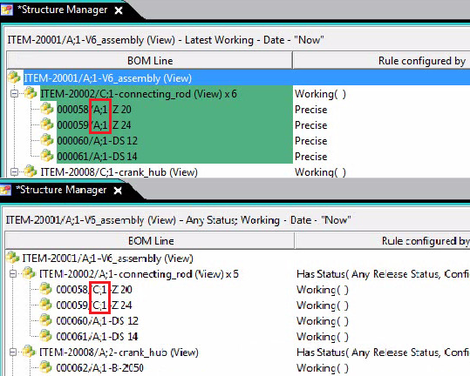 Fig. 8 Precise and Imprecise
- Revision Rules-
Revision rule is parameter we set to determine which item revisions appear in the product structure. By changing revision rule, we can view different configuration of assembly. In fig.9 Migration revision rule is applied.
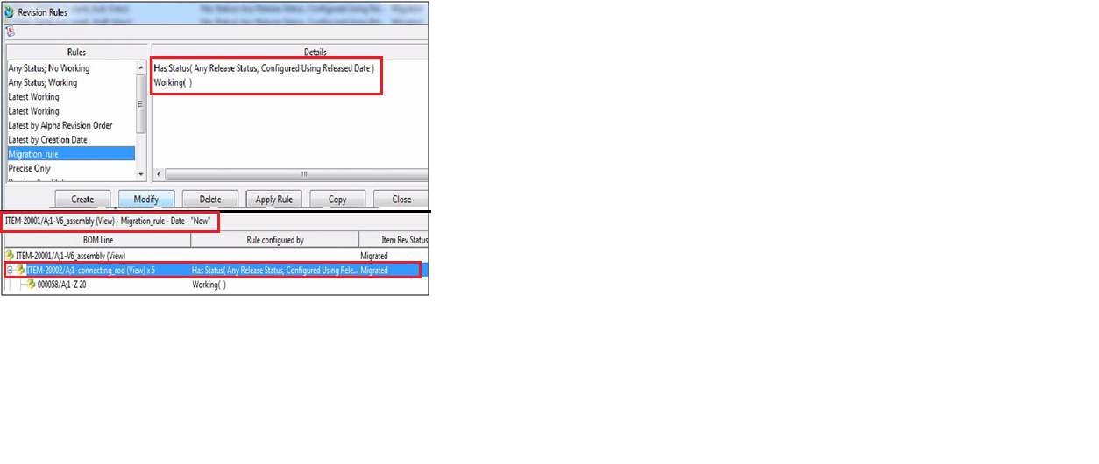 Fig. 9 Revision Rule

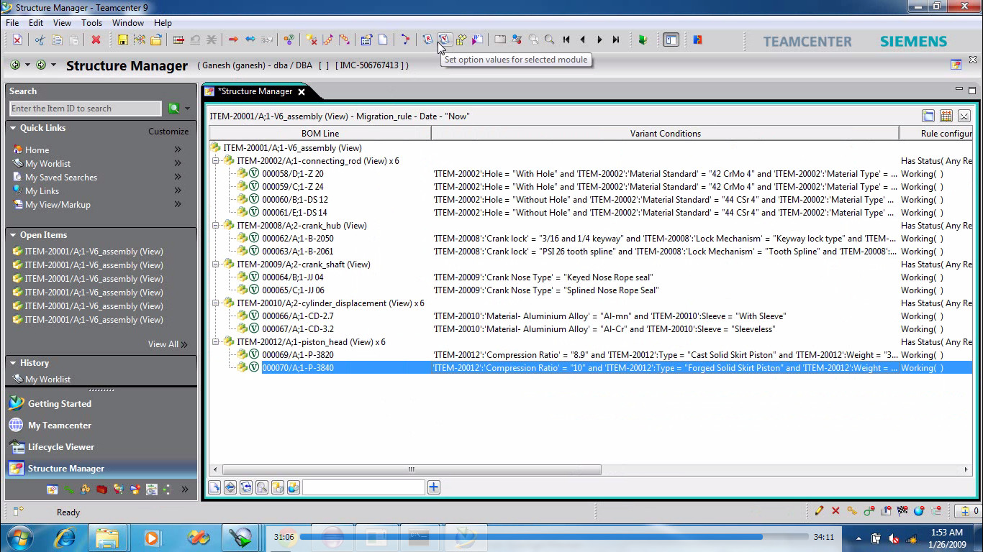

Fig. 10 Variant Condition

- Variant Configuration-
Variants allow you to create options (for example, colour) and allowed values of those options (for example, black and silver) and associate them with an item revision. You usually do this at a top-level assembly, but you can implement variants anywhere in the structure. Configure variant for V6_assembly having two variants as 2657cc and 3165cc.Here now get two different structure for V6_assembly in one product structure. We do not need to maintain two different product structures. In fig.10 shows applied a different variant condition for components. Then need to set configuration on revision-“ITEM-20001/A-1-V6_assembly” for 2657cc engine type. This configuration is shown in fig.11. The variant configuration of V6_assembly for 2657cc is activated by selecting Show un-configured variants button from view r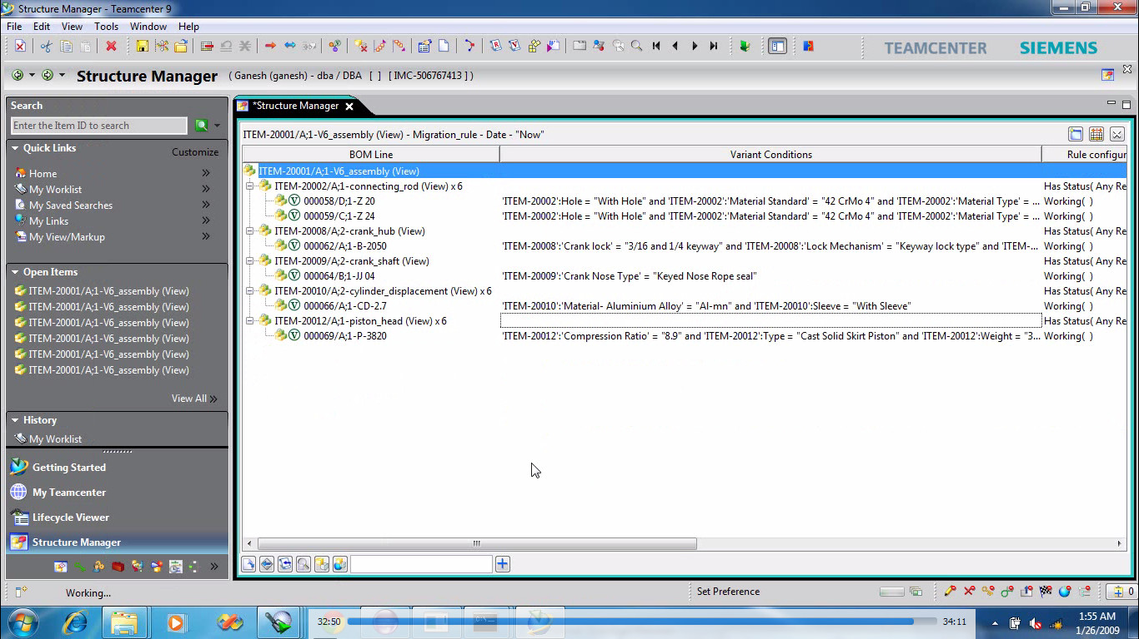ibbon of structure manager and shown in fig.12.
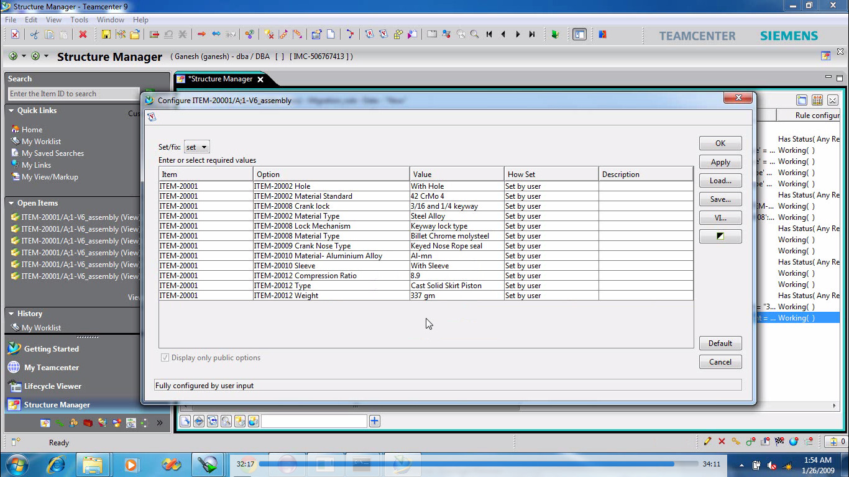 Fig. 11 Configuration Set For 2657cc Engine

Fig. 12 V6_assembly for 2657cc Engine

- Teamcenter Customization
- Server Side Customization-
The server side customization can be done by using Teamcenter API (Application program interface) called as ITK (Integration Toolkit), C /C++. This is a set of software tools uses to integrate third party or user-developed applications with Teamcenter [14].
TABLE I
Modules of Teamcenter API’s
Module | Used for
POM | User Interface and Administration
AOM | Implementation like Load, Save, Delete
AE | Dataset Related (Find, Export, Create)
ITEM | Item Related (Create, find)
FL | Folder Related (Create, Update)
SA | System Administration (Create , Set)
GRM | Relation Set (Create, Save)
PREF | Preference Related (Ask, Delete, Export)
EMH | Error Related (Store, Clear, Ask)
QRY | Query Related (Find, Execute, Set )
IMF | File Related (Copy, Read)
MAIL | Mailings Related (Add, Create, find)
ADA | License Related
EMH | Workflow Related (Ask, Apply)

- Post-action BOM customization requirement-

Created post action for assigning a project of parent item to child component while creating assembly in structure manager. Post-Action means automatic operation of action after completion of base action. When user will create an assembly by using Item having project assigned to it, then child component is being used by user should get assigned to same project. The customization code is creates custom ‘project.dll’ by help of Visual studio 2008 project. This custom ‘project.dll’ is preferred in Teamcenter. In fig.14 project PAJERO is automatically assigned to the Item Revision 000070/A-1-crank_shaft shown in properties table [13].
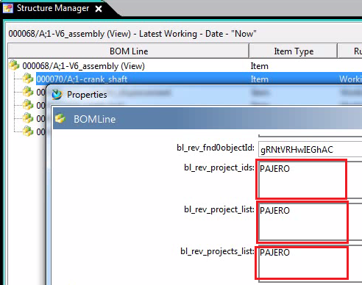
Fig. 14 Post-Action Result
- Pre-condition BOM customization requirement-
Created pre-condition of checking for user is from Engineer group while creating assembly in structure manager. If user belongs to Engineer group then teamcenter alloy him to create assembly. Otherwise give him custom massage Error. The customization code is creates custom ‘CheckRole.dll’ by help of Visual studio 2008 project. This custom ‘CheckRole.dll’ is preferred in Teamcenter. Fig.15 shows error massage after checking role condition [13].
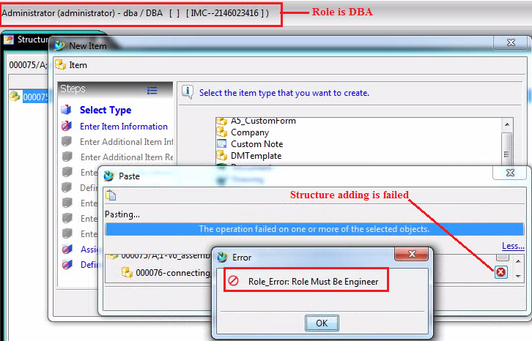Fig.15 Pre-Condition Result

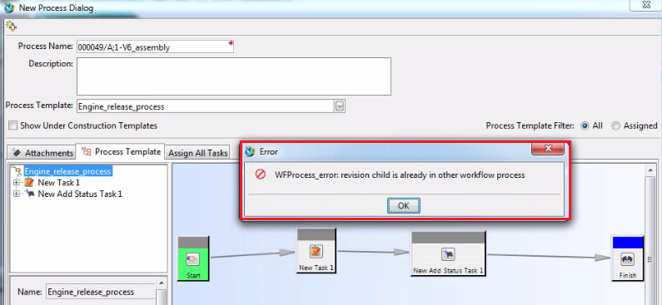

Fig. 16 Rule-Handler Result

- Rule-Handler for BOM customization Requirement-
Create a custom rule handler for set condition on BOM line during workflow initialization, so that it will check each child and its subchilds in BOM at any level are in any process or not!! If any child revision in workflow process then custom rule handler avoid the workflow initialization and give custom massage. The customization code is creates custom ‘WFProcess.dll’ by help of Visual studio 2008 project. This custom ‘WFProcess.dll’ is preferred in Teamcenter. In fig.16
On Item revision 00049/A-1; V6_assembly apply a workflow process but its one or more BOM child is already in other process. That mean present in my worklist. On Engine_Release_Process workflow added custom Rule-Handler, so this handler checks condition. Here condition is not satisfied so that workflow is not initiate and show custom error massage [13].
- Generating custom Report for BOM customization Requirement –
Company requirement is generating custom report in “.csv” format and attaching them to parent item revision as a dataset by Batch utility customization. The new created custom dataset contains information of BOM Line name string, owning user of item revision, dataset name and type attached to any level of BOM line. For this requirement need to provide input as Item id of parent BOM line.
Batch utility customization required to run two files: compile.bat and linkitk.bat in command prompt of Teamcenter. This custom report decreases effort of user for validation of Dataset. User gets all dataset name and type information attaches to all BOM line by opening only one file. In fig.17 after applying batch utility programme a excel dataset is attaches to the parent Item revision and dataset_report.csv is attached as named reference [13].
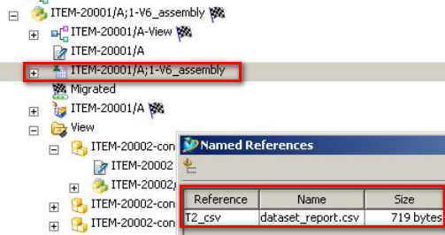Fig. 17 Custom Dataset Report Attaches to Parent Item Revision

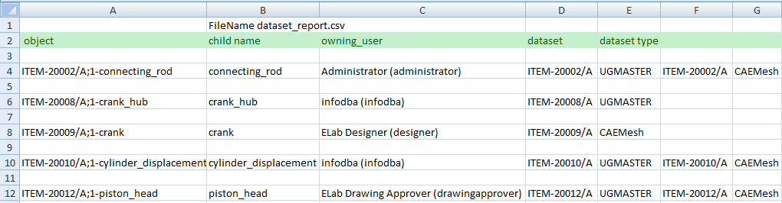Fig. 18 Custom Dataset_report.csv File with Information

- Conclusions
Data migration is important stage when one of the organisation implements new system for product data management. For Migration of NX CAD data of old system into new Teamcenter system by ug_import tool is an effective way. By this tool data successfully migrated without loss of any data and error. The BOM management is important and critical task in PLM system. Throughout the lifecycle of a product high numbers of revisions in BOMs are created. Configuration of BOM depends on product information and requirement of organization. The Teamcenter most used and usable PLM solution to provide effective BOM management in organizations. BOM management of one business case of V6_assembly is implemented by different functionalities of teamcenter. The variant configuration of BOM is most effective method for managing product structure of different variant. Customization of teamcenter is required for various business needs, for increasing PLM system requirement and for legal requirements.
Following benefits can be drawn from Teamcenter customization for companies BOM requirements:
- Creation of Post-Action for assigning project automatically to BOM child’s
- Creation of Pre-Condition for checking of user role while creation of BOM
- Creation of rule-Handler for workflow checks BOM child’s are in worklist or not
- Creation of custom report in csv format of dataset attached to BOM child’s for easy of dataset validation
Acknowledgment
I am highly indebted to my guide Prof. A. U. Gandigude for his guidance and constant supervision as well as for providing necessary information regarding the work & also for his support in completing this Research Paper. He has been a constant source of inspiration to me. He is responsible for giving me the confidence and courage throughout this course work. Also, I want to express my gratitude to FaithPLM Solutions, Pune for giving me the opportunity to work on such an interesting and challenging subject.

- Global Alternatives-
A global alternate is allowing interchange of part with another part in BOM level’s where the part is used in the product structure. We can apply global alternate applies to any revision of the part and is independent of any views. Here revision “000078-Part 2”is global alternate of revision “000077-Part 1”. The symbol of global alternative is appear in front of “000077/A-1-Part 1” shown in fig.13

References
- S. K. Tekale, V. M. Nandedkar, “PLM Implementation with Creation of Multiple Item using SOA Technology in Team center”, IOSR Journal of Mechanical and Civil Engineering, ISSN(e) : 2278-1684, pp : 62-66.
- Janhavi Bonde, Suhasini Itkar, “PLM Customization for Generating Variant Bill of Materials Offline of Teamcenter”, International Journal of Science and Research (IJSR), Volume 3 Issue 6, June 2014, pp-2566-2572.
- Siemens PLM Software, “Teamcenter for bill of materials Management- Managing BOM-related product definitions across the entire product lifecycle”,2011.
- Janhavi Bonde, Suhasini Itkar, “A Review on Variant BOM Management methods in PLM”, International Journal of Advanced Research in Computer Science and Software Engineering, Volume 4, Issue 6, June 2014, pp. 245-251.
- Arena PLM, www.arenasolution.com
- Jaykumar Yoga Mule, “PLM based Customization for Extraction of NX Assembly from Teamcenter to Local Drive”, International Journal of Applied Information Systems (IJAIS), Volume 2– No.6, May 2012,pp-27-33.
- D. Dutta, J.P. Wolowicz (Eds.), An Introduction to Product Lifecycle Management (PLM), ISPE, 2005.
- S.G. Lee, Y.-S. Ma, G.L. Thimm, J. Verstraeten, “Product lifecycle management in aviation maintenance, repair and overhaul”, Computers in Industry 59, 2008, pp- 296–303.
- Manoj Tiwari, “Teamcenter PLM: Bill of Material Concept”, Available: http://teamcenterplm.blogspot.in/2014/01/bill-of-material-concept.html
- Siemens PLM Software, “Teamcenter for bill of materials management-Managing BOM-related product definitions across the entire product lifecycle”, 2008.
- Design Fusion, “Bill of Materials Management”, Available: http://www.designfusion.com/teamcenter.html
- Teamcenter 9.1 Help: Structure Manager Guide.
- FaithPLM, Solutions, Pune.
Teamcent

